Task Pool:

1. Given as input an integer number of seconds, print as output the equivalent time in hours, minutes and seconds. Recommended output format is something like

*7322 seconds is equivalent to 2 hours 2 minutes 2 seconds.*

1. Write a program that asks the user to enter two numbers, obtains them from the user and prints their sum, product, difference, quotient and remainder.
2. Write a program that reads in the radius of a circle and prints the circle’s diameter, circumference and area. Use the constant value 3.14159 for π. Perform each of these calculations inside the printf statement(s) and use the conversion specifier %f.
3. Write a program that prints the numbers 1 to 4 on the same line. Write the program using the following methods.

a) Using one printf statement with no conversion specifiers.

b) Using one printf statement with four conversion specifiers.

c) Using four printf statements.

1. Write a program that prints the following shapes with asterisks.

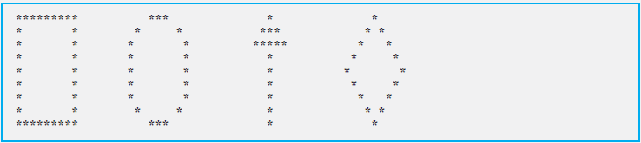

1. Create a BMI calculator application that reads the user’s weight in pounds and height in inches, then calculates and displays the user’s body mass index.

